DS 735: Communicating About Data

Writing in Plain Language

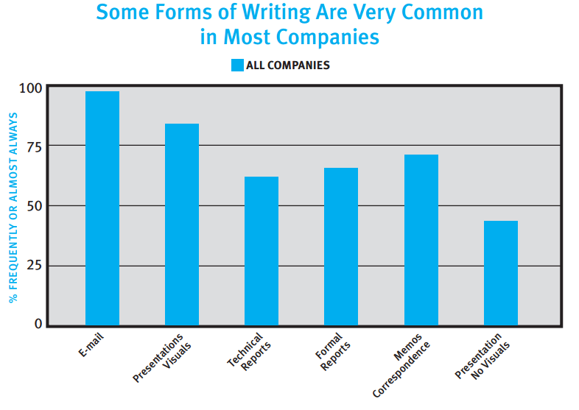

Article Excerpt: College Board, Writing: A Ticket to Work...Or a Ticket Out, A Survey of Business Leaders.

Link: <https://www.nwp.org/cs/public/download/nwp_file/21479/writing-a-ticket-to-work-or-a-ticket-out.pdf?x-r=pcfile_d>

**Writing in Plain Language**

1. **Technical Communicator Competencies.** A great deal of technical and applied research has been conducted to better understand the nature of effective technical communication. The [*Society for Technical Communication*](http://www.stc.org/) is a professional association dedicated to the advancement of technical communication. Let’s consider four technical writing competencies synthesized by Hart-Davidson: experimentation, collaboration, abstraction, and system thinking.

Article Excerpt: On Writing, Technical Communication, and Information Technology: The Core Competencies of Technical Communication

Article Link: <https://www.msu.edu/~jmonberg/415/Schedule_files/hart-davidson_thecore.pdf>

Article Citation: Hart-Davidson, W. (2001). On writing, technical communication, and information technology: The core competencies of technical communication. *Technical Communication*, 48(2), 145-155.

1. **Principles of Effective Written Communication**
   * 9 *Easy-to-Read NYC* Written Communication Principles
     1. Use a plain language approach to communications
     2. Define the purpose of your written document
     3. Include only important and directly relevant information
     4. Use simple language
     5. Keep sentences and paragraphs short
     6. Make it personal
     7. Use the active voice
     8. Use easy-to-read design techniques
     9. Assess the usability of documents: listen to your readers
   * 3 Goals of Analytic Writing,
     1. Reader should recognize goals or recommendations
     2. Reader should be able to judge the quality of the underlying analysis
     3. Document should be an effective tool for the reader
   * 8 Deadly Sins of Analytic Writing
     1. Extravagance--too many words
     2. Gluttony--too much information
     3. Sloth--making the reader do your job
     4. Confusion--lack of clarity or purpose
     5. Anger--vague or emotional writing
     6. Pride--style over function
     7. Arrogance--disregarding instructions
     8. Bonus: Writing sample
   * 5 Steps of Plain Language Writing
     1. Step 1: Identify and describe the target audience. The audience definition works when you know who you are and are not designing for, what they want to do, and what they know and need to learn.
     2. Step 2: Structure the content to guide the reader through it. The structure works when readers can quickly and confidently find the information they are looking for.
     3. Step 3: Write the content in plain language.
     4. Step 4: Use information design to help readers see and understand. The design works when users notice and use the signposts to move through the information efficiently.
     5. Step 5: Work with the target user groups to test the design and content. The document or site works when target users can find what they need, understand what they find, and act on it confidently.

3. **Website: Plain Language Federal Guidelines**

* The use of plain language is spreading in many areas of American culture. Governments at all levels, especially the federal government, are using plain language more extensively.
* Site Link: <http://www.plainlanguage.gov/index.cfm>